|  |  |
| --- | --- |
| Nhci 631assignment  Sebola Faro -202215274 |  |

Part A: Discovering Requirements

1. Identifying a Real-World Student Problem

Problem Space: Balancing Academic Work and Mental Health

For many students, managing the demands of school alongside their mental and physical well-being is a real challenge. Stress, burnout, and trouble keeping organized often come into play, especially with all the assignments and deadlines piling up. Here are some common struggles:

* Mental Load: Students are often trying to juggle numerous assignments, exams, and extracurriculars, which can lead to feeling overwhelmed and anxious.
* Class Reminder Fatigue: Continuous reminders about classes and deadlines can feel exhausting and may cause students to overlook or forget important tasks.
* Poor Planning: A lot of students find it tricky to organize their study schedules, which can lead to procrastination, last-minute cramming, and missed deadlines. There’s a noticeable lack of structured routines.

This situation makes it clear that we need a smart app to help students keep track of both their academic responsibilities and wellness activities, making it easier to juggle everything while also looking after their mental health.

2. User Research (Interviews with 3 Students)

To get a clearer picture of what students need and the problems they face, I spoke with three students from different backgrounds.

Student 1: Alex (Undergraduate Student, Age 20)

* Academic Focus: BED
* Pain Points: Struggles with remembering assignment deadlines, frequently feels stressed during exam periods, and often procrastinates until the last minute.
* Needs: Wants reminders for assignments and study sessions, needs help with staying organized and managing time effectively.

Student 2: Karabo (undergraduate Student, Age 23)

* Academic Focus: BA
* Pain Points: Overwhelmed with research deadlines and classwork, experiences burnout from lack of structured breaks, and finds it difficult to schedule self-care activities.
* Needs: Needs an app that helps her balance academic work and personal well-being, such as wellness check-ins and study break suggestions.

Student 3: Jack (Graduate Student, Age 21)

* Academic Focus: Diploma in ICT
* Pain Points: Finds it hard to track multiple ongoing tasks and manage overlapping deadlines, feels that he neglects mental health in favor of academic priorities.
* Needs: Requires a way to organize tasks by priority, integrate with class schedules, and receive reminders for both academic tasks and wellness breaks.

3. Personas

Persona 1: Alex (Undergraduate Student)

* Age: 20
* Academic Focus: B.ED
* Goals:
  + Manage assignments and deadlines efficiently.
  + Avoid last-minute cramming.
  + Stay on top of all academic responsibilities.
* Pain Points:
  + Frequently forgets assignments and tasks.
  + Experiences stress due to lack of time management.
  + Needs better reminders and a structured study plan.
* Technology Usage:
  + Regularly uses a smartphone for reminders.
  + Active on social media and uses productivity apps.
* Preferred Features:
  + Task reminders and deadlines.
  + Progress tracking and completion percentage.
  + Study schedule planner with break reminders.

Persona 2: Karabo (undergraduateStudent)

* Age: 23
* Academic Focus: BA
* Goals:
  + Balance academic responsibilities with wellness.
  + Maintain mental and physical health during stressful periods.
  + Plan out study sessions and research deadlines effectively.
* Pain Points:
  + Often forgets to take breaks and suffers from burnout.
  + Finds it hard to manage long research deadlines while maintaining self-care.
  + Overwhelmed by constant work pressure and classwork.
* Technology Usage:
  + Regularly uses health apps (for mood tracking, mindfulness).
  + Frequently uses digital calendars to schedule meetings and deadlines.
* Preferred Features:
  + Wellness check-ins for stress and mood tracking.
  + Suggestions for breaks and mindfulness activities.
  + Integration with academic calendar for seamless study planning.

4. Usage Scenarios

Scenario 1: Alex Receives a Task Reminder

* Context: Alex is in the middle of studying but is unsure if he has any assignments coming up.
* Action: The app sends a push notification reminding him of an upcoming assignment deadline in two days. He checks the notification and opens the app, which displays his list of tasks, including the due date for the assignment.
* Outcome: Alex marks the assignment as a priority, sets a study session reminder, and feels reassured that he is on track. The notification helps him avoid procrastination.

Scenario 2: Karabo Uses the Wellness Check-in Feature

* Context: Karabo is feeling stressed after a long day of research and study. She realizes she hasn't taken a break in hours.
* Action: She opens the app and is prompted by the wellness feature to check in on her mood. She selects "Stressed" and is given a suggestion for a 15-minute meditation break and a reminder to drink water.
* Outcome: Karabo takes a break, feels more relaxed afterward, and returns to her work with renewed energy, better able to manage her workload and wellness.

In summary:

* User Research: We conducted interviews with three students to grasp common pain points related to academic stress and wellness.
* Personas: From feedback, we developed two personas: Alex (an undergraduate) and Karabo (a postgraduate) based on their needs and frustrations.
* Usage Scenarios: We created two scenarios: one where Alex gets task reminders and another where Karabo uses wellness check-ins for managing stress.

Part B: Designing the Conceptual Model

1. Core Functionalities, Interaction Types, and Interface Metaphor

Core Functionalities:

1. Task Manager: This is the main feature of the app, allowing users to keep track of their assignments and deadlines. Students can easily add new tasks, set due dates, mark them as complete, and make edits or remove tasks when needed.
2. Push Notification Reminders: To keep users on top of their game, the app sends timely reminders for upcoming deadlines and tasks. Users can customize notifications to remind them at their preferred intervals.
3. Wellness Check-ins: This feature prompts users to check in on their mood and stress levels regularly. It helps users stay mindful of their mental well-being by offering suggestions for breaks or mindfulness activities.
4. Study Planner: A calendar integration that syncs with school schedules to assist students in planning their study sessions. It recommends optimal study times based on upcoming deadlines and existing commitments.
5. Progress Tracking: This keeps tabs on task completion and overall progress, visually showing how much of their workload has been tackled over time.

Relevant Interaction Types:

1. Instructing: Users can interact with buttons to add, edit, or delete tasks. These buttons are the main way to manage tasks and deadlines.
2. Conversing: The wellness check-in feature uses a friendly, conversational style to ask users about their mood and mental state, providing customized responses or suggestions.
3. Manipulating: Users can easily drag-and-drop tasks or events within the calendar to reschedule them, offering a more hands-on and adaptable way to plan study time.
4. Observing: The progress tracking feature lets users visually see their completion status through charts or percentage indicators, giving feedback on their productivity.

Fitting Interface Metaphor:

Digital Planner: The app acts like a digital planner, organizing both academic tasks and wellness activities in one convenient space. It is a personal assistant for managing tasks, deadlines, and mental health, allowing users to have a structured yet flexible overview of their academic journey.

2. Conceptual Model Diagram and Narrative

1.Conceptual Model Diagram:

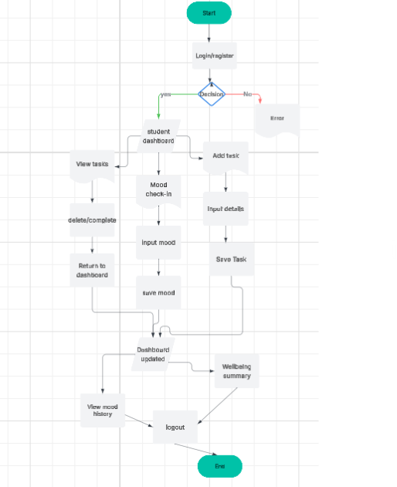

Narrative Overview:

In the design of the Context-Aware Student Academic and Wellness App, the User takes center stage, interacting with all the app's main features.

1. Task Manager:

* The Task Manager is a key feature that allows users to create and manage their tasks. You can add new tasks, set due dates, edit tasks, and mark them as done or still pending.
* Interaction Type: Instructing—users can use buttons for actions like "Add Task," "Edit Task," and "Delete Task."

1. Push Notification Reminders:

* After creating tasks, the app sends timely reminders to keep users on track. These notifications alert users about upcoming deadlines and can be personalized to fit their preferences.
* Interaction Type: Observing—users get notifications and can check the status of their upcoming tasks through alerts.

1. Wellness Check-ins:

* The app encourages users to regularly reflect on their mental and physical health. This includes tracking mood and offering suggestions for breaks or mindfulness activities based on the responses given. This feature supports users in maintaining a healthy balance between studying and well-being.
* Interaction Type: Conversing—users answer questions about their mood or stress levels, and the app responds with feedback and helpful advice based on their answers.

1. Study Planner:

* The Study Planner connects with the user’s academic calendar, helping them organize study sessions. It offers personalized suggestions for when to study based on class schedules and deadlines. Plus, users can easily adjust their events or study times as needed.
* Interaction Type: Manipulating—users can drag and drop study sessions to reshape their study schedules.

1. Progress Tracking:

* The app features a visual progress tracker that shows how much of the user’s task list has been accomplished. This helps students keep an eye on their academic progress over time, boosting their motivation and focus on their goals.
* Interaction Type: Observing—users can see their progress through a percentage bar or graph that updates as they complete tasks.

This conceptual model uses a Digital Planner as the main interface, making it easier for students to manage both academic and wellness needs in a straightforward way. The different interaction types create a smooth experience that balances ease of use with engaging features, helping users juggle their academic responsibilities while also taking care of their mental health. It emphasizes how each part of the app is interconnected, ensuring a user-friendly and effective system.

Part c

1.Sketch diagrams

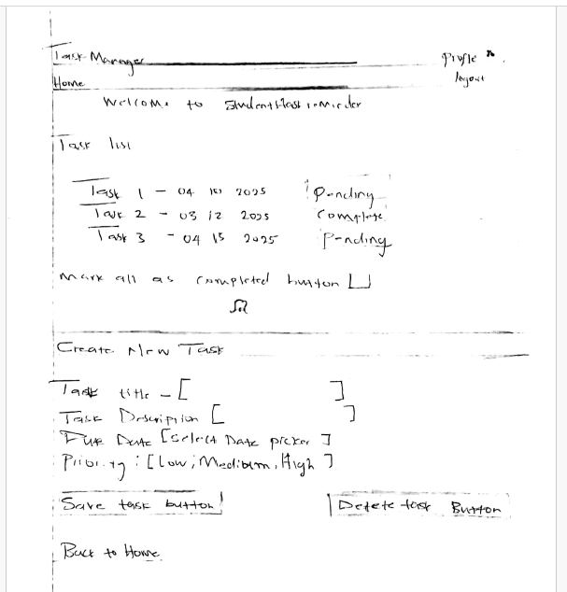

2. Interaction Elements + Design Principle Annotations

1. Add Task Page

Interface Elements:

* Text Input – Task Title
* Text area – Task Description
* Date Picker – Due Date
* Dropdown – Priority Level (Low, Medium, High)
* Button – “Add Task”
* Alert Box / Message Area – Confirmation after task is submitted

Design Principles Applied:

| Element | Principle | Annotation/Explanation |
| --- | --- | --- |
| Task Title Input | *Visibility* | Clearly labeled input with placeholder text ("Enter task title") |
| Priority Dropdown | *Mapping* | Options are logically ordered (Low → High), making it easy to understand and select |
| Add Task Button | *Affordance* | Styled as a clickable button (raised, colored) to signal action |
| Confirmation Message | *Feedback* | After submitting, a green success alert appears ("Task added successfully!") |
| Consistent Layout | *Consistency* | All forms follow the same structure across pages |
| Required Fields | *Constraints* | Shows error if required fields are left empty |

2. Mood Check-In Page

Interface Elements:

* Mood Selection Buttons/Emojis – Happy , Sad , Stressed
* Optional Note Area – “Write about your day…”
* Submit Button – “Submit Mood”
* Feedback Message – "Thanks for checking in today!"

Design Principles Applied:

| Element | Principle | Annotation/Explanation |
| --- | --- | --- |
| Mood Emoji Buttons | *Recognition* | Easy to recognize moods visually (reduces need for reading) |
| Submit Button | *Affordance* | Large and centered, looks like an actionable item |
| Feedback Alert | *Feedback* | Message appears to confirm mood submission, reducing uncertainty |
| Optional Text Area | *Flexibility* | Allows journaling for users who want to express more, while keeping it optional |
| Emojis Grouping | *Grouping/Layout* | Buttons are grouped together, clearly showing a single-choice selection area |

Screenshots:

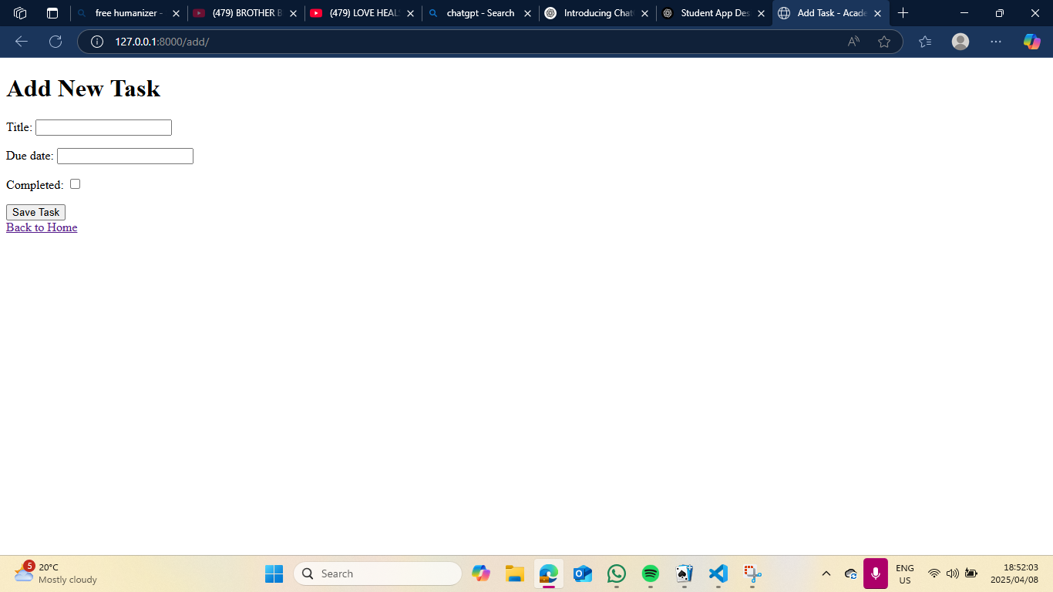

Part D: Evaluation Planning

1. Usability Goals and UX Goal

* Usability Goal 1: Task Completion Efficiency
* We want the application to allow users to quickly add, update, or remove tasks and reminders with just a few clicks. A good task management system should be smooth and uncomplicated, making it easier for users to perform essential tasks like entering new assignments or marking off completed ones.
* Usability Goal 2: Learnability
* The app needs to be simple to learn, especially for those who are using it for the first time. Clear navigation, simple instructions, and intuitive design can help users quickly grasp how to use all the features without any hassle. The aim here is to keep things straightforward and give users a pleasant introduction to what the app can do.
* UX Goal: User Engagement
* We want to create a positive experience for users by making task management and wellness tracking fun. By incorporating personalized notifications, reminders, and engaging content, our goal is to encourage users to interact with the app every day. An enjoyable user experience will help us keep users coming back long-term.

2. User Testing Questions

1. How easy was it for you to add a new task or reminder in the app? Did the process make sense to you?
2. Did you face any issues or confusion when moving between different sections of the app (like the task list or wellness check-in)?
3. Were the reminders helpful in keeping you on track with your assignments and wellness activities?
4. What features or improvements do you think would make your experience better and help you manage tasks or wellness more effectively?

3. Evaluation Method

Think-Aloud Testing

Relevance:

Think-aloud testing is a technique where users interact with the app and share their thoughts and actions as they navigate through it. This approach is fantastic for discovering usability issues like unclear instructions or confusing navigation. When users articulate their reasoning for each action, testers can see exactly where they hesitate or make mistakes, which gives valuable insights into the app's usability.

For our academic wellness app, think-aloud testing will show us how easy the task creation process is, whether the wellness features are clear and useful, and how smooth the overall user experience is. This method helps us determine issues that might be missed with other testing methods, allowing us to create a more user-friendly design.

Part E: Reflection

User-Centered Design: What I Learned

Working on this project has really opened my eyes to the incredible importance of a user-centered design (UCD) approach when creating applications that genuinely meet users’ needs. By including real users in the design process—like through interviews and by creating personas—I gained a better understanding of their pain points and what matters most to them. This emphasis on user experience means that the final product not only works well but also connects with users on a more personal level. I learned that by pinpointing the actual challenges that students face—like juggling academic tasks and taking care of their well-being—my app can offer real solutions. Using feedback from personas like Alex and Sarah enabled me to refine features, making them much more relevant to their everyday lives. It also emphasized how important it is to keep testing and adjusting the design based on what real users experience.

Challenges of Applying Conceptual Modeling

Creating a conceptual model for the app wasn’t a walk in the park—it came with a bunch of challenges, especially when it came to organizing and structuring how different features interact, like managing tasks, tracking wellness, and setting reminders. One of the biggest challenges was figuring out how to blend all these components into a smooth user experience without overwhelming anyone. For instance, finding the right balance between the task list and wellness check-ins involved carefully considering the user interface and how interactions should logically flow. The conceptual model needed to be adaptable for future updates while still providing a clear experience for users. Another struggle was defining interaction types and metaphors that users could easily grasp. While designing the app as a “digital planner” sounded great in theory, turning that concept into an intuitive interface meant going through several iterations to simplify the user’s journey.

Experience with Sketching and Django Wireframe Development

Sketching the interfaces turned out to be a really eye-opening exercise, helping me visualize the layout and overall flow of the application. It was a fantastic way to map out the basic structure and interactions before diving into the technical details. Through sketching, I could play around with various layouts, features, and the location of buttons—like the Save and Delete buttons for tasks—making sure that the most essential actions were easy to find. This sketching phase revealed spots where users might run into trouble and helped guide future development decisions.

On the tech side, diving into Django wireframe development was a hands-on way to change those sketches into a working interface. However, I faced important learning curves when it came to setting up the right file structure, managing templates, and making sure the routing was spot on. While the idea of integrating models, views, and templates seems straightforward, I revealed some complexities around setting up database models, querying tasks, and getting data to display correctly. Even with these challenges, the process was deeply rewarding and gave me a much clearer understanding of web development frameworks and how they tie into user interface design. Overall, it was a genuinely valuable learning experience that connected conceptual design with real-world application.

In conclusion

Aware Student Academic and Wellness App aims to provide a comprehensive solution for students to manage their academic responsibilities and maintain their mental well-being. Through user research, personas, and usage scenarios, we have identified key pain points and needs of our target users. Our conceptual model and design principles guide the development of an intuitive and user-friendly app that promotes academic success and wellness. Future development and testing will focus on refining the app's features and ensuring a seamless user experience. By prioritizing user needs and well-being, we can create an app that makes a positive impact on students' lives.

Github prop link:

<https://github.com/Farosebola/HCI_assignment.git>

Folder:academictasks